Recruitment Pack

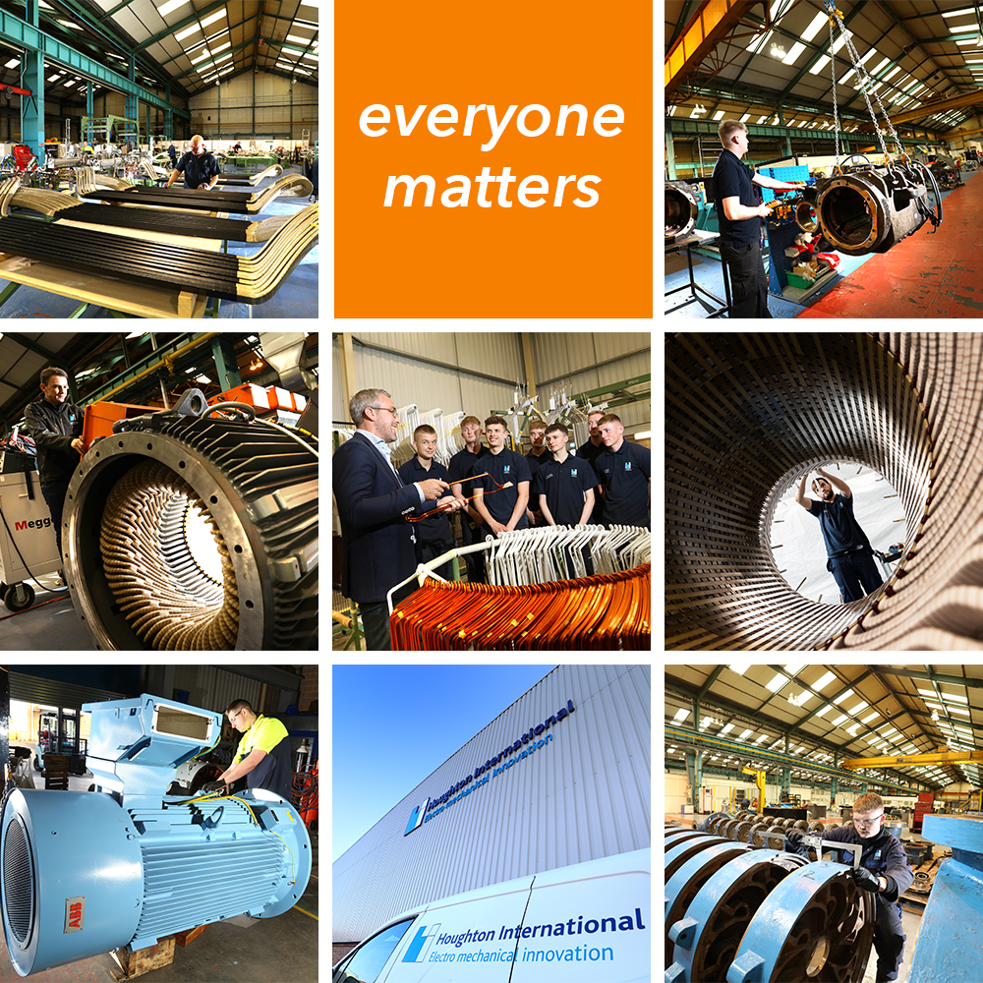

Sales Administrator

Salary: £22,300 - £25,000
Reports to: Business Development Manager
Contract Type: Permanent
Division: Central Services – Sales
About Houghton International:
Houghton International improves the performance of electro mechanical assets around the world. We use our technical expertise to work with customers to solve their problems offering a high-quality repair and maintenance service for motors, generators, pumps and all electrical rotating equipment.
Within the business we have hundreds of years of knowledge and experience across a range of sectors including rail, industrial and power generation. We are innovative, flexible and responsive to customer’s needs, continually exceeding industry standards and customer expectations. As the world continues to electrify and the demand for power rises, our products and services will become even more valuable and our business will continue to grow.
We recognise that people are our most important asset. We have a highly skilled team that successfully combines youth with experience and we invest in our people to be ‘the best in the world at what we do’.
We employ for attitude and train for skill and our industry leading training programme is award winning. We aim to be the employer of choice for talented people across the whole of the North East, providing opportunities to develop and supporting our employees to achieve their goals. In return we expect commitment, a total focus on our customers’ needs, flexibility to meet deadlines and dedication to our quality process.
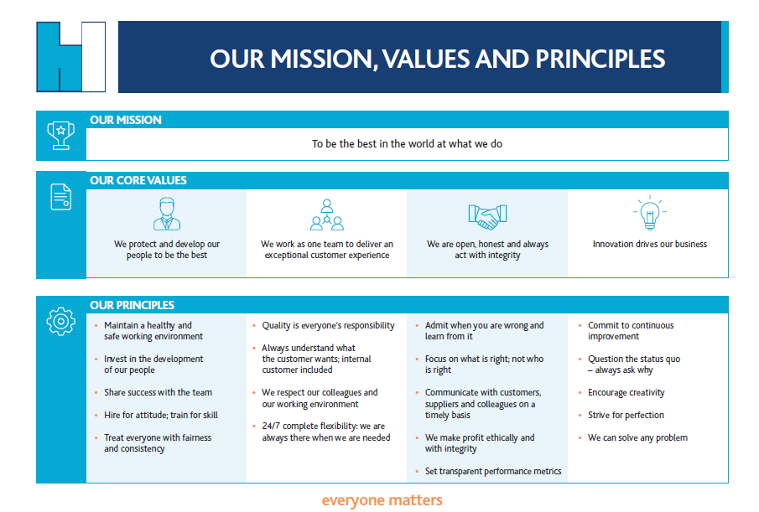

Are You:
- Friendly, team worker, helpful and act in a professional manner?
- Able to communicate with customers at all levels, both in the UK and overseas?
- Organised, self-motivated and can work using your own initiative and prioritise workloads?
- Flexible, innovative with great attention to detail?
- Interested in joining a dynamic team at a critical juncture of its growth journey?
Would you like to be part of a team that:
- Is striving to be the best in the world at what we do
- Is committed to driving business growth and development
- Is expanding into new sectors and markets globally
- Is increasing market share year on year
- Develops innovative solutions and market leading products
- Exports to over 30 countries world wide
- Has an industry leading, award winning, training and development programme
- Supports companies such as Rolls Royce, RWE and ABB to develop cutting edge power generation technology
- Is highly skilled, and customer focused with innovation at its core
- Invests in apprentices and training across the business to support business growth and personal development.
If so, then read on to find out more about the role and how it supports our strategic business objectives.
Job purpose:
Due to continued business growth, we have an opportunity for a Sales Administrator to join our growing team. The successful candidate will work with and support the business development manager, business development executives, sales director, the wider sales team as well as operations to support with the creation, business development and growth objectives across a range of target sectors regionally, nationally and internationally.

Duties and responsibilities:
Key responsibilities include but are not limited to:
- Provide full administration support to the wider sales team across all departments / sectors.
- Respond to, prepare and submit quotations in line with customer deadlines.
- Building in depth knowledge of customers and prospects individual needs and objectives
tracked via CRM and the CRM data and processes.
- Monitor and update the CRM ensuring all customer data is accurate
- Regularly liaise with customers and prospects to update on status.
- Assist the Sales team with the preparation and completion of supplier questionnaires.
- Providing excellent customer service to both internal and external customers.
- Complete customer satisfaction surveys and report on findings.
- Liaising with operations when completing and supporting with tenders and PQQs.
- Strong appreciation of continuous improvement delivering excellent customer care and
satisfaction.

This is a varied and busy role that requires you to have exceptional organisational skills, be self-motivated and can work using your own initiative and prioritise workloads.

Typical qualities of the successful candidate will include:

 | Essential | Desirable
Qualifications  - GCSE (Maths and English C or above) or equivalent | ✓
Key skills/knowledge  - Industry experience.  - Excellent IT Skills – MS Office / Excel.  - Knowledge of EMIR or a CRM systems | ✓ | ✓  ✓
Competencies/behaviours  - Working to strict deadlines.  - Self-motivated.  - Strong customer service skills.  - Listening skills.  - Highly organised.  - Strong verbal and written communication skills.  - Team working.  - Ability to occasionally travel | ✓  ✓  ✓  ✓  ✓  ✓  ✓  ✓
Experience  - Previous experience gained within a similar role.  - Previous experience in a fast-paced environment  - Strong administration experience including preparation of tenders, estimates and letter writing.  - Building strong professional relationships with customers.  - Maintaining a client database.  - Report writing.  - Handling customer enquiries.  - Providing statistical information to Senior Management | ✓  ✓  ✓  ✓  ✓  ✓  ✓ | ✓

Working Pattern Conditions:

Based at our head office in Newcastle upon Tyne. Standard working hours 8am to 4.30pm Monday to Thursday and 8am to 3.30pm on a Friday. Some travel may be required throughout the year. A full UK Driving license is desirable but not essential.

Working at Houghton International

At Houghton International ‘everyone matters’ and in return for our employees’ commitment and hard work everyone enjoys a range of benefits additional to their salary so that everyone can continue to share in the company’s continuing growth and ongoing success.
As a Houghton International employee, you benefit from:
- Contributory pension scheme – above standard minimum
- Income protection insurance – to supplement SSP should you be unable to work
- Death in service insurance – 2 x annual salary to a beneficiary of your choice
- Training and personal development programme – Individual PDP plans
- Holiday buy/sell – option to buy or sell up to 5 days holiday for added flexibility
- Health Assessments – ongoing surveillance to improve wellbeing
- Social events – opportunities to celebrate success as a team
- Better Health at Work Gold Award employer
- Good Work Pledge At Work Advanced Award

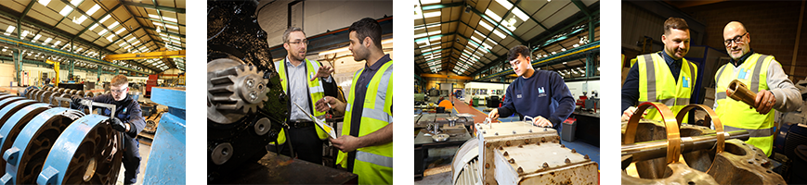
Houghton International is a growing business, having grown 25% year on year for the past 3 years, that operates across a diverse range of sectors. Our employees have a wide range of skills including engineering, manufacturing, fitting, winding, operations support, administration and sales to support our customers and meet their delivery requirements.
Innovation is at the heart of our business and we have a genuine problem-solving approach to all aspects of delivery, working flexibly with customers to improve the performance of their machines and coming up with solutions to their issues.
Working alongside our skilled and experienced teams, some of whom have worked here for over 30 years, we offer valuable training and real progression opportunities combined with a varied and engaging work load in a safe and friendly environment.
Apply now to be part of an innovative and growing SME that values its employees and reinvests in the business to secure its long-term future, sharing its success as it grows.
Forward your CV to careers@houghton-international.com and tell us why you would like to be considered for this role.

