Recruitment Pack

Finance Apprentice

Salary: Min wage+5% up to £19,000
Benefits: Full sick pay + all other company benefits
Reports to: Julie McSherry, Finance Manager
Contract Type: Permanent, Full Time
Division: Central Services

About Houghton International:
Houghton International improves the performance of electro mechanical assets around the world. We use our technical expertise to work with customers to solve their problems offering a high-quality repair and maintenance service for motors, generators, pumps and all electrical rotating equipment.
Within the business we have hundreds of years of knowledge and experience across a range of sectors including rail, industrial and power generation. We are innovative, flexible and responsive to customer’s needs, continually exceeding industry standards and customer expectations. As the world continues to electrify and the demand for power rises, our products and services will become even more valuable and our business will continue to grow, we are working towards a target revenue of £20million by 2020/21.
We recognise that people are our most important asset. We have a highly skilled team that successfully combines youth with experience and we invest in our people to be ‘the best in the world at what we do’.
We employ for attitude and train for skill and our industry leading training programme is award winning. We aim to be the employer of choice for talented people across the whole of the North East, providing opportunities to develop and supporting our employees to achieve their goals. In return we expect commitment, a total focus on our customers’ needs, flexibility to meet deadlines and dedication to our quality process.
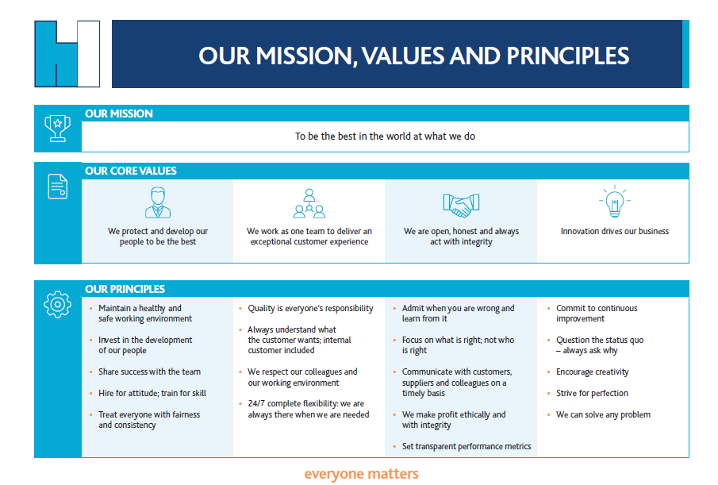

Are You:
- Friendly and energetic with a desire to work hard whilst developing new skills?
- Interested in studying towards an accountancy/business qualification(AAT) whilst gaining valuable hands on experience within a varied finance role?
- A person who has excellent attention to detail, with the ability to work to a high level of accuracy?
Would you like to be part of a team that:
- Is striving to be the best in the world at what we do
- Driving business growth and development to achieve a turnover of £20million by 2020
- Expanding into new sectors and markets globally
- Increasing market share year on year
- Develops innovative solutions and market leading products
- Exports to over 28 countries world wide
- Has an industry leading, award winning, training and development programme
- Supports companies such as Rolls Royce, Siemens and ABB to develop cutting edge power generation technology
- That is highly skilled, and customer focused with innovation at its core
- Invests in apprentices and training across the business to support business growth and personal development.
If so, then read on to find out more about the role and how it supports our strategic business objectives.
Job purpose:
Due to promotion, we have an opportunity for a Finance Apprentice to join our growing team. The successful candidate will be mainly focussed on Accounts Payable and Stock Maintenance but will provide support to the Finance Team across all areas. The role will change and develop as the candidate moves through the AAT accountancy qualification to ensure relevance to the studies. As we are a small finance team, there is the opportunity to be involved in a variety of activities.
Finance Assistant duties and responsibilities:
Key responsibilities include:

Accounts Payable

- Administration of accounts payable, employee expenses and company credit card expenditure
- Accurately record invoices from suppliers within the financial system, ensuring relevant authorization obtained
- Ensure all employee expenses and credit cards are supported by relevant documentation and authorized
- Reconcile accounts payable ledger to supplier statements
- Prepare supplier payments for uploading
- Process all capital invoices and ensure entered onto Fixed Asset Register
- Dealing with all parts of business on rectifying any purchase queries
- Communicate with external suppliers where necessary
Stock Maintenance
- Set up new stock parts when required
- Complete random monthly cycle checks to ensure accuracy of stock
- Assist with bi-annual stock takes
Month End
- Calculate and post accrual journals for utilities, rates, workwear and any other relevant costs
- Reconcile purchase orders to statements, working with operations team and suppliers.
- Complete stock report, calculate stock provision and post relevant journals
- Assist Finance Team with month end process to ensure timely close
Adhoc Tasks
- Provide general support to the Finance team as and when required.
- Study towards AAT qualification

Typical qualities of the successful candidate will include:

 | Essential | Desirable
Qualification:  - GCSEs A-C (or equivalent), including maths  - A level/GNVQ qualified (or equivalent) |  | 
Key skills/knowledge:  - Interest in business and finance  - Experience working with Microsoft Office, particularly Excel |   
Competencies/behaviours:  - Excellent attention to detail to ensure a high level of accuracy  - Ability to work to strict deadlines  - Excellent communication skills, both written and verbal  - Organised and methodical approach to work  - Ability to work both alone and as part of team  - Maintain confidentiality at all times |           

Working Pattern Conditions:

Based at our head office in Newcastle upon Tyne. Standard working hours 8am to 4.30pm Monday to Friday and 8am to 3.30pm on a Friday. Salary depending on experience, with opportunity for progression. Some travel may be required on occasion for training and/or supplier visits.

Working at Houghton International

At Houghton International ‘everyone matters’ and in return for our employees’ commitment and hard work everyone enjoys a range of benefits additional to their salary so that everyone can continue to share in the company’s continuing growth and ongoing success.
As a Houghton International employee, you benefit from:
- Fully funded apprentice training package
- Contributory pension scheme – above standard minimum
- Income protection insurance – to supplement SSP should you be unable to work
- Death in service insurance – 2 x annual salary to a beneficiary of your choice
- Training and personal development programme – Individual PDP plans
- Holiday buy/sell – option to buy or sell up to 5 days holiday for added flexibility
- Staff recognition and engagement – discretionally bonus and quarterly awards
- Health Assessments – ongoing surveillance to improve wellbeing
- Social events – opportunities to celebrate success as a team
Apply via https://www.getmyfirstjob.co.uk/discover/job/100053/1/accountancy/newcastle-upon-tyne/finance-apprentice-with-houghton-international to be part of an innovative and growing SME that values its employees and reinvests in the business to secure its long term future, sharing its success as it grows.

